Yes, you can be gay and Christian
By Ross Murray, Published: June 19, 2013 at 10:06 am
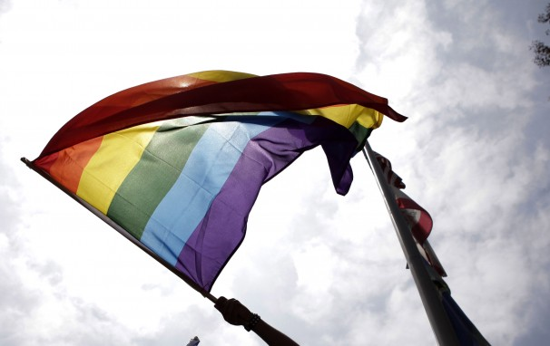
A same sex marriage advocate waves a rainbow flag at a protest in Los Angeles. (Jae C. Hong/AP )
The Pew Research Center released a study last week that examined the lives of LGBT Americans. One portion of the study, which has garnered significant media attention is the relationship between LGBT people and religion. The study found that LGBT people tended to be less religiously affiliated than the general population, and views all major religions as unfriendly toward LGBT people.
The Pew study found that just less than half (48 percent) of LGBT people have no religious affiliation which is significantly more than the 20 percent of the general public.
Some anti-gay activists will look at this figure and say, “Aha! See? Those LGBT people are anti-Christian. Look, half of them even eschew religion of any kind!”
This figure is largely of their own making. There was a time when religion (all of them) were solidly anti-gay. Human sexuality wasn’t discussed, except in hushed tones and fraught with shame. If someone came out, they had to leave everything behind. Often, their job, their family, and their faith community. While those bad old days don’t exist in the same way they once did, the stigma lingers.
Don’t believe me? Take a look at another statistic coming from the Pew study. It found that a third of religiously-affiliated LGBT adults find a conflict between their faith and their sexual orientation or gender identity. A third of people who still are religiously affiliated still feel that same conflict.
And what is even more telling is that the general population sees even more of a conflict.
“About three-quarters of white evangelical Protestants (74 percent) and a majority of all U.S. adults with a religious affiliation (55 percent) say homosexuality conflicts with their religious beliefs. Among all adults in the general public, there is a strong correlation between the frequency of church attendance and the belief that homosexuality should be discouraged.”
The stigma is still propagated. Even when LGBT people have reconciled their faith and their sexual orientation or gender identity, there are those actively trying to reestablish that inner conflict.
This was demonstrated by GLAAD’s study, Missing Voices: A Study in Religious Voices in Mainstream Media Reports about LGBT Equality, which was released last year. It found that three out of four religious spokespeople who spoke about LGBT issues were from denominations that had anti-LGBT policies or culture.
The dominant impression is that religion is inherently anti-LGBT, and the amount of work that the Religion, Faith & Values program of GLAAD, the LGBT religious organizations like the Gay Christian Network, Muslims for Progressive Values, or Keshet, alongside of so many denominational LGBT advocacy groups, has not yet changed that perception.
It also means that, for those denominations who are LGBT-inclusive, or who have made strides to become more LGBT inclusive, that there is still more work to do. The task is probably greatest for LGBT-affirming people in non-affirming religious traditions. Marianne Duddy-Burke noted what the study meant for LGBT-affirming Catholics in an article on the Huffington Post.
“If we want Catholicism to be identified as a hostile institution by four out of five LGBT people, and by many of those who support us, then let the bishops continue to own “Catholic, Inc.” However, if we truly believe in the baptismal identity we reaffirm each Easter season and want our church to be seen as a help and haven for those in need, it is time for Catholics to claim a leadership role within our church, much as we have done in the public square. We must begin to take on the bishops when they act in ways that are contrary to our central creed that God is incarnate in all humans, including LGBT people and those who love and support us.”
I say this last part as a Christian and as a gay man. LGBT and allied people of faith need to speak up. Not only for the good of the LGBT community, have who continued to face conflict in religious communities. We also need to speak up for the good of our own faith. I do the work that I do because I care about the reputation of my church in the world. If you truly love your faith and LGBT people, you must make that known. It is only by speaking out that we change the negative perception surrounding our faith communities.

Ross Murray is Director of News and Faith Initiatives at GLAAD.

